Bash scripting -2

start

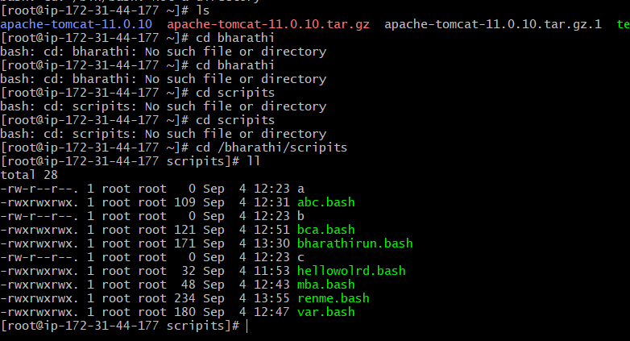

Open git bash and change the sudo su – users to root

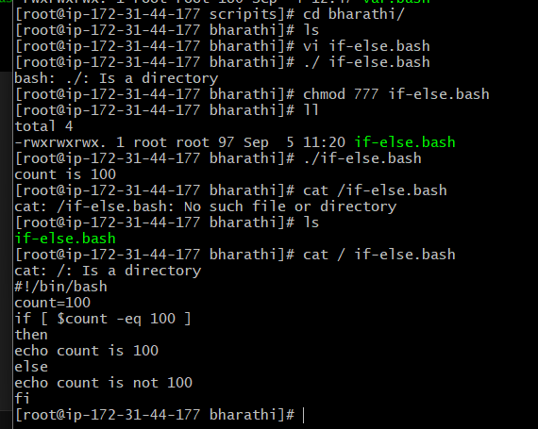

Creating a file and executing the if-else method scripting

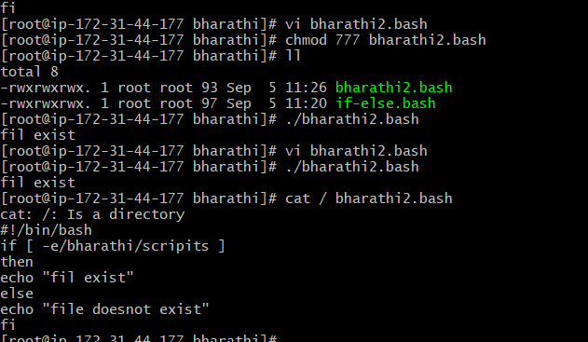  
checking file exists if-else

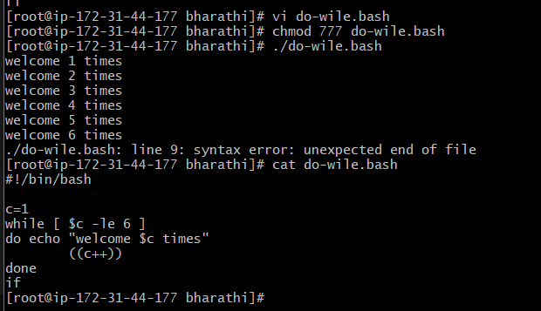

Executing do while scripts

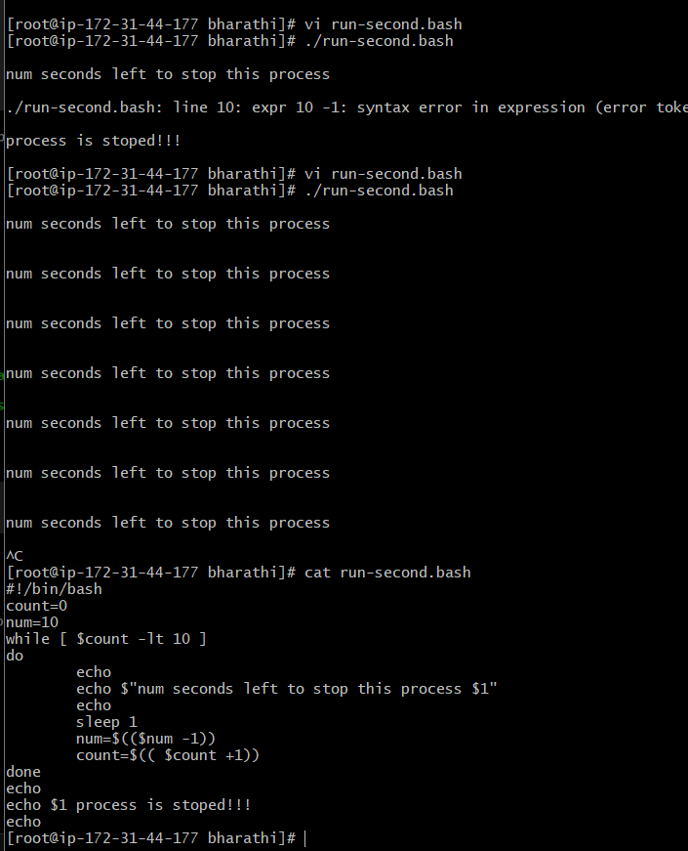

Scripting to run for number of seconds

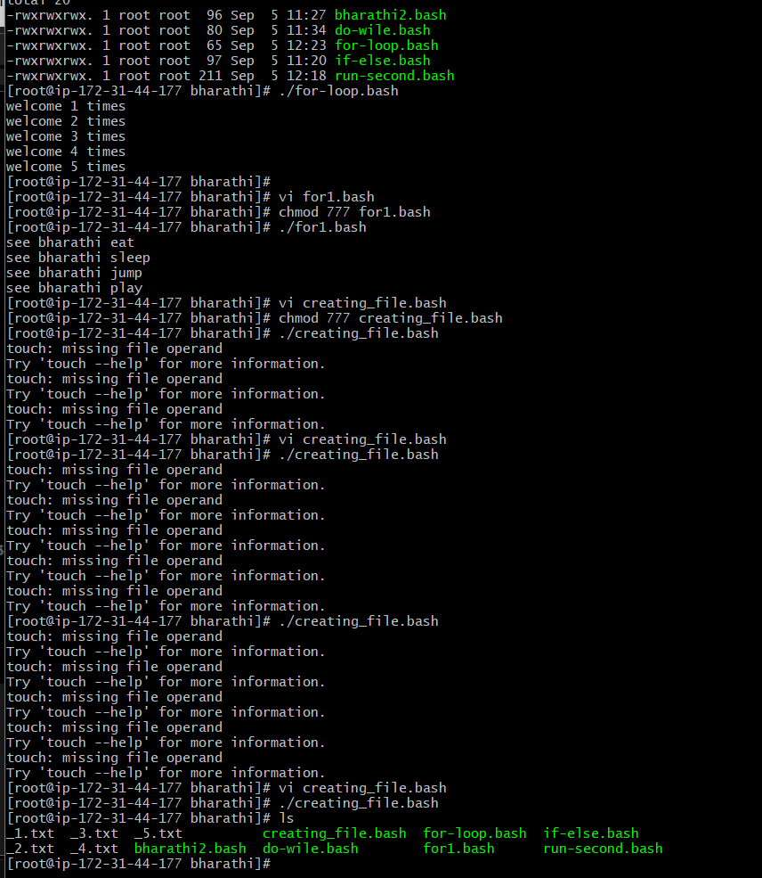

For scripting, creating a .txt file

Thens for loop is also executing

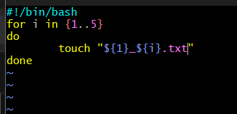

for loop to create 5 files named 1-5

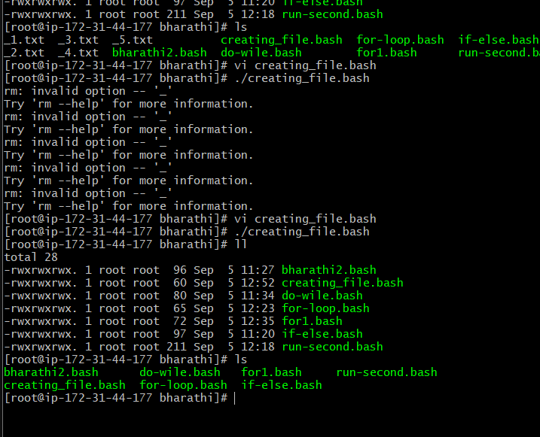

for loop to delete 5 files named 1-5

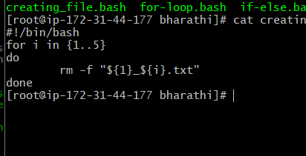

Specify days in for loop

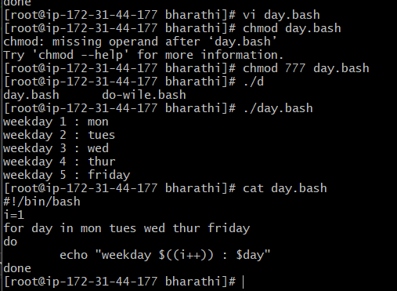

List all users one by one from /etc/passwd file

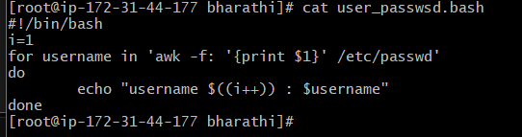

If then scriptis executing

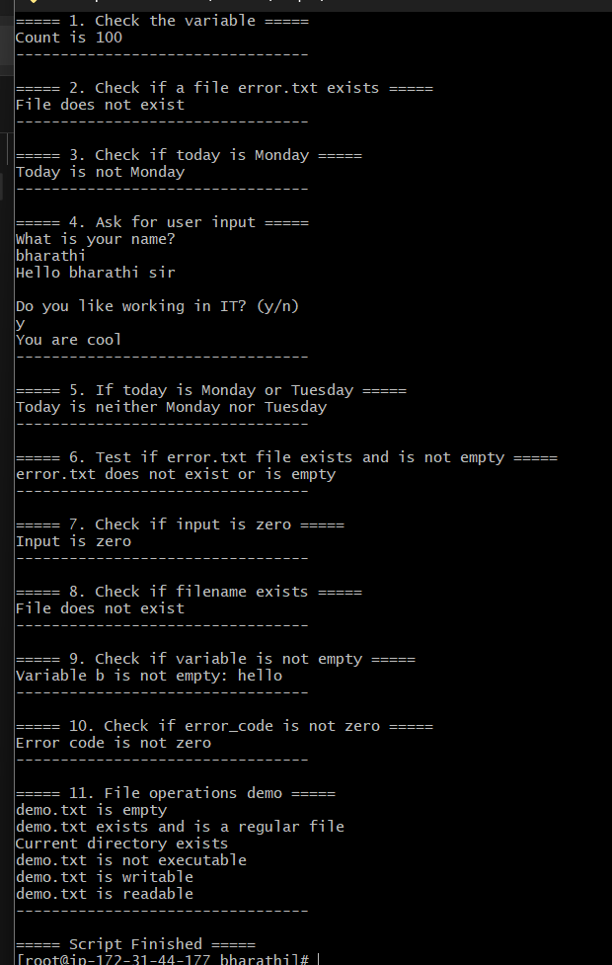

#!/bin/bash

clear

echo "===== 1. Check the variable ====="

count=100

if [ $count -eq 100 ]

then

echo "Count is 100"

else

echo "Count is not 100"

fi

echo "---------------------------------"

echo

echo "===== 2. Check if a file error.txt exists ====="

if [ -e /home/iafzal/error.txt ]

then

echo "File exists"

else

echo "File does not exist"

fi

echo "---------------------------------"

echo

echo "===== 3. Check if today is Monday ====="

a=$(date | awk '{print $1}')

if [ "$a" == Mon ]

then

echo "Today is $a"

else

echo "Today is not Monday"

fi

echo "---------------------------------"

echo

echo "===== 4. Ask for user input ====="

echo "What is your name?"

read name

echo "Hello $name sir"

echo

echo "Do you like working in IT? (y/n)"

read Like

if [ "$Like" == y ]

then

echo "You are cool"

elif [ "$Like" == n ]

then

echo "You should try IT, it’s a good field"

fi

echo "---------------------------------"

echo

echo "===== 5. If today is Monday or Tuesday ====="

if [ "$a" = Mon ] || [ "$a" = Tue ]

then

echo "Today is either Monday or Tuesday"

else

echo "Today is neither Monday nor Tuesday"

fi

echo "---------------------------------"

echo

echo "===== 6. Test if error.txt file exists and is not empty ====="

if test -s error.txt

then

echo "error.txt exists and is not empty"

else

echo "error.txt does not exist or is empty"

fi

echo "---------------------------------"

echo

echo "===== 7. Check if input is zero ====="

input=0

if [ $input -eq 0 ]

then

echo "Input is zero"

else

echo "Input is not zero"

fi

echo "---------------------------------"

echo

echo "===== 8. Check if filename exists ====="

if [ -e /export/home/filename ]

then

echo "File exists"

else

echo "File does not exist"

fi

echo "---------------------------------"

echo

echo "===== 9. Check if variable is not empty ====="

b="hello"

if [ "$b" != "" ]

then

echo "Variable b is not empty: $b"

else

echo "Variable b is empty"

fi

echo "---------------------------------"

echo

echo "===== 10. Check if error_code is not zero ====="

error_code=1

if [ "$error_code" != "0" ]

then

echo "Error code is not zero"

else

echo "Error code is zero"

fi

echo "---------------------------------"

echo

echo "===== 11. File operations demo ====="

file="demo.txt"

touch $file

if [ -s $file ]; then echo "$file exists and is not empty"; else echo "$file is empty"; fi

if [ -f $file ]; then echo "$file exists and is a regular file"; fi

if [ -d . ]; then echo "Current directory exists"; fi

if [ -x $file ]; then echo "$file is executable"; else echo "$file is not executable"; fi

if [ -w $file ]; then echo "$file is writable"; fi

if [ -r $file ]; then echo "$file is readable"; fi

rm -f $file

echo "---------------------------------"

echo

echo "===== Script Finished ====="